Join a meeting without a Teams account
Microsoft Teams
Mobile
Even if you do not have a Teams account, you can still join a Teams meeting on the mobile app. Here is how:
- In the meeting invite, select Join Microsoft Teams Meeting.
- If you do not already have the Teams mobile app, you will be taken to your app store to download it.
- Download the app and open it right from the app store page.
Teams will ask if it is okay to use your mic. Be sure to allow it so others in the meeting will be able to hear you.
- Next, you will be given two options for joining your meeting: Join as a guest or Sign in and join. Choose Join as a guest. Type your name and tap Join meeting.
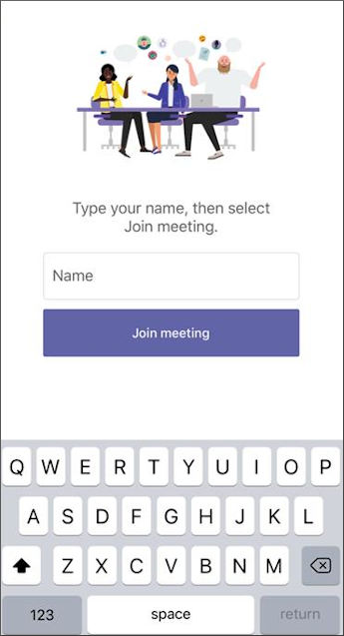
- Once you are in the meeting, you can turn your video or mic on or off by tapping on the center of your screen to show the meeting controls. Tap again to hide them.

